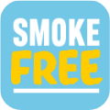

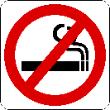 Smoke-free homes
Dr Hobson’s video https://www.youtube.com/watch?v=VuY8PQ4lLzs

A smoke-free home protects your loved ones
By stopping smoking, you'll help to protect your non-smoking friends and family, too.
Breathing in secondhand smoke increases the risk of lung cancer, heart disease and stroke.
In children, it doubles the risk of getting chest illnesses, including pneumonia, ear infections, wheezing and asthma.
They also have 3 times the risk of getting lung cancer in later life compared with children who live with non-smokers.
Visit www.nhs.uk/live-well/quit-smoking to find out about the stop smoking treatments available on the NHS and find out how to get started with stopping smoking.
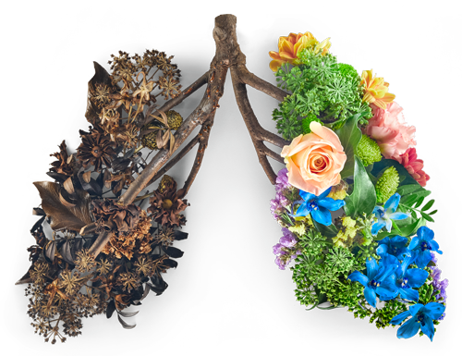

Children and passive smoking
Passive smoking is especially harmful for children as they have less well-developed airways, lungs and immune systems.
Children who live in a household where at least 1 person smokes are more likely to develop:
- asthma
- chest infections – like pneumonia and bronchitis
- meningitis
- ear infections
- coughs and colds
Children are particularly vulnerable in the family car where secondhand smoke can reach hazardous levels even with the windows open.
To protect children, a ban on smoking in cars and other vehicles carrying children was introduced in October 2015. It is now against the law to smoke in a private vehicle if there's a young person under 18 present.

Passive smoking

Secondhand smoke is dangerous, especially for children. The best way to protect loved ones is to quit smoking. At the very least, make sure you have a smokefree home & car.
When you smoke a cigarette (or roll-up, pipe or cigar), most of the smoke doesn't go into your lungs, it goes into the air around you where anyone nearby can breathe it in.
Secondhand smoke is the smoke that you exhale plus the "sidestream" smoke created by the lit end of your cigarette.
When friends and family breathe in your secondhand smoke – what we call passive smoking – it isn't just unpleasant for them, it can damage their health too.
People who breathe in secondhand smoke regularly are more likely to get the same diseases as smokers, including lung cancer and heart disease.
Pregnant women exposed to passive smoke are more prone to premature birth and their baby is more at risk of low birthweight and cot death.
And children who live in a smoky house are at higher risk of breathing problems, asthma, and allergies.
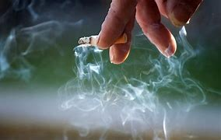

How to protect against secondhand smoke
The only way to protect your friends and family from secondhand smoke is to keep the environment around them smoke free.
The best way to do that is to quit smoking completely. If you're not ready to quit, make every effort to keep your cigarette smoke away from others and never smoke indoors or in the car.
You should:
- always smoke outside
- ask your visitors to smoke outside
- not smoke in the car or allow anyone else to
Take steps NOW to stop smoking.
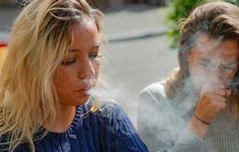
Source: www.nhs.uk/live-well/quit-smoking
www.nhs.uk/better-health

USEFUL LINKS

Smokefree Homes Campaign – West Midlands Fire Service
https://www.youtube.com/watch?v=jto3vNCbJRE

Better Health Campaign
https://www.youtube.com/watch?v=A_MU3a5sbcQ

https://www.nhs.uk/better-health/quit-smoking/

https://www.nhs.uk/conditions/stop-smoking-treatments/

Other Smokefree Campaigns in Walsall
https://go.walsall.gov.uk/news/news_details/birchills-in-walsall-backs-smokefree-campaign-at-school-gates

